Kenneth Campbell

Homework 1 Report

Development Process:

1. Install Python
2. Import modules
3. Set up server socket
4. Configured server to start listening for requests
5. Calibrated the validation of user requests received
6. Configured exception handling
7. Configured server to return the requested data, if valid / permitted
8. Tested program
9. Composed Project Report

Impression(s):

This project was very easy and definitely helps teach students about how a web server actually carries out its function. The instructions were well composed, the only thing I would suggest is better explaining what you expect in terms of this report. There was not much of a clear outline with regards to what you wanted us to put in this file.

Status of the Program:

Runs without error.

Challenges Faced

Initially had issues with parsing the user’s request (resolved)

Had issue with security / the permission control aspect of the algorithm (resolved)

Resources Used:

www.Google.com

www.Stackoverflow.com

www.Geeksforgeeks.com

Results:

If pathway exists on the server, is a file, and user has permission

http://localhost:6789/HelloWorld.html

Response: 202

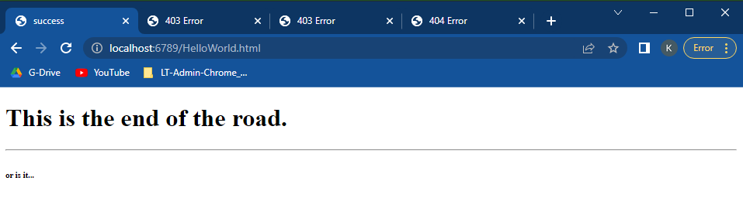

If pathway exists on the server, is a file, and user does not have permission

http://localhost:6789/students/invalid.html

Response: 403

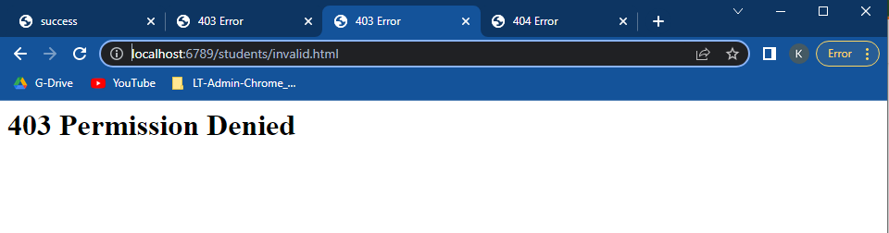

If pathway exists on the server and is not a file

http://localhost:6789/students/

…or… http://localhost:6789/students

Response: 403

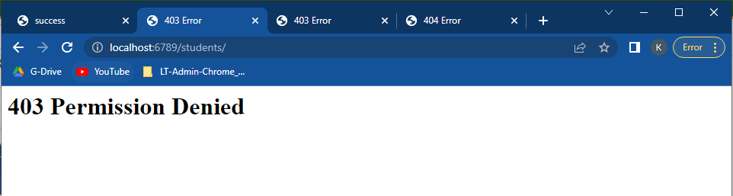

If pathway does not exist on the server

http://localhost:6789/fake-file.html

Response: 404

